Livestock Producer Stabilization Grants
Frequently Asked
Questions
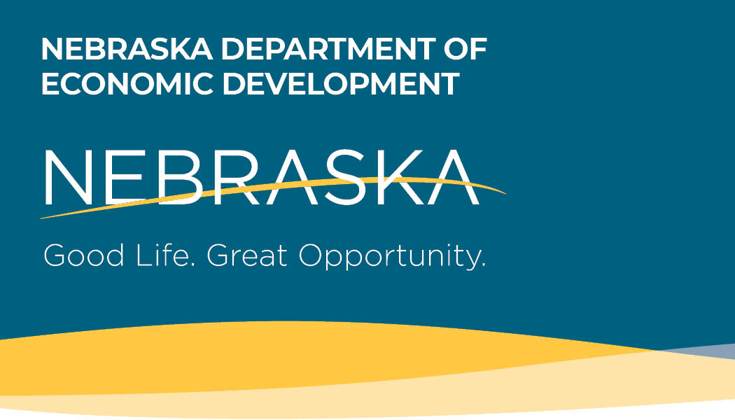

On March 27, 2020, President Donald J. Trump signed into law the Coronavirus Aid, Relief, and Economic Security Act (the “CARES Act”) which provides federal stimulus funding to states and local governments to help with the response to and recovery from the novel coronavirus (“COVID-19”).
What is the Nebraska Livestock Producer Stabilization Grant Program?
The Livestock Producer Stabilization Grant Program provides financial assistance to Nebraska livestock producers who have been severely impacted by COVID-19. Small businesses and livestock producers in our state are the lifeblood of our economic system, and their survival and growth are paramount. Stabilization Grant assistance is intended to provide working capital to livestock producers by way of grants that can be used for operating expenses.

Who is eligible to apply?
A Nebraska livestock producer is eligible for the grant if they derive 2/3 of their gross income from farming or ranching and are in the following NAICS Codes: NAICS 112111: Beef Cattle Ranching and Farming; NAICS 112120: Dairy Cattle and Milk Production; NAICS 1122: Hog and Pig Farming; NAICS 1123: Poultry and Egg Production; and NAICS 1124: Sheep/Goat Farming. To be eligible, a producer must also have 1-10 employees, at least 20 animal units, and must have suffered a business loss from the COVID-19 pandemic.

Are any businesses ineligible to apply for this program?
The following businesses are not eligible to apply:

- Livestock producers with more than 10 employees
- Livestock producers with fewer than 20 animal units
- Livestock producers that do not derive 2/3 of their gross income from farming or ranching
- Livestock producers that are not listed in the following NAICS Codes: 112111, 112120, 1122, 1123 or 1124
- Livestock producers past due on Nebraska taxes
- Livestock producers currently listed on the federal debarment or suspension list (available online at SAM.gov)

What are eligible uses of funding?
Eligible uses of Livestock Producer Stabilization Grant funding include working capital and any operational expenses for the continuation of business operations.

Are there any prohibited or excluded uses of funds?

The following are not eligible uses of funds:

- Lobbying
- Damages covered by insurance
- Duplication of benefits, including expenses that have been or will be reimbursed under any other federal program
- Reimbursement to donors for donated items or services
- Workforce bonuses other than hazard pay or overtime
- Severance pay
- Legal settlements

Is a producer guaranteed money if approved?
No. Grant money will be distributed on a first come, first served basis.

Will the application process be available in Spanish?
Yes

What are the key program deadlines?
Event | Date(s)
Eligibility submission opening date | June 15, 2020
Eligibility submission deadline | June 26, 2020
Eligibility notification date (via email from the State) | June 15,2020-June 26, 2020
Application begin date | June 15, 2020
Application deadline | June 26, 2020
Grant Award deadline date | August 1, 2020
Period of performance | December 31, 2020

What supporting documentation is required?
Applicants must provide contact information along with their social security number, driver’s license number, federal and state tax identification numbers, industry NAICS Code, and their number of employees as of March 13, 2020, as represented by their 941N or other tax records. They will also need to know how many animal units they have, and their bank routing information. Various other documentation may be requested to demonstrate the negative impact COVID-19 has had on the applicant’s business.

What is the process to apply for a Livestock Producer Stabilization Grant?
A livestock producer must fill out an Eligibility Certification Form online at www.getnebraskagrowing.nebraska.gov and provide applicable supporting documentation by June 26, 2020. If the business is deemed eligible, it will receive an email with a certification number and be sent a link to fill out the full application.

Will all eligible livestock producers receive funding, or is this a competitive process?
All funding will be awarded on a first come, first served basis. It is anticipated that each eligible livestock producer will receive a minimum of $12,000 to help offset the negative impacts of COVID-19 on their operations.

How were eligibility requirements determined?
Eligibility was based on information collected by the Office of the Governor, the Get Nebraska Growing Task Force and the Nebraska Department of Economic Development (DED), based on the manner in which limited federal funds could be put to use to help the most people and make the biggest economic impact.

Why are livestock producers with over 10 employees not included in this funding?
The State of Nebraska understands that there is great interest in this program; however, funding limitations require that grant dollars be distributed in a manner that serves as many small businesses as possible and makes the largest possible impact given the resources available. If all categories of business were served, funding would quickly diminish without making a substantial impact for anyone involved.

Will any of the grant money have to be repaid?
No, this is a grant and will not be paid back. However, there will be a post-award review, and repayment will be required on the basis of inaccurate or false information.

Will Livestock Producer Stabilization Grant money be taxable income?
Consult your tax preparer.

What kind of technical assistance is available to help complete the application process?
Call the Get Nebraska Growing hotline at 855-264-6858 between 7:30 AM and 6:00 PM CST, Monday-Friday.

What is the deadline to apply for the funding?
A business must be deemed eligible and complete a full application by 6:00 PM CST on June 26, 2020.

When determining eligibility, how is the number of employees calculated for each livestock producer?
The number of employees is determined by how many persons you had working for you on March 13, 2020. A copy of your 941N, Schedule F or the First page of your most recent tax return will be required.

To be considered eligible for the Livestock Producer Stabilization Grant, what portion of a business’ gross income should be attributable to farming or ranching activities?
At least two-thirds.

Is a business owner considered an employee?
Yes.

Do 1099 or contract employees qualify as employees?
No.

Can the employee count be based on the Full-Time Equivalency (FTE) of all my employees?
No.

Does the employee count include both full-time and part-time employees?
Yes. This is not an FTE measurement. For example, if you had seven full-time and three part-time employees, you would have an employee count of 10 and be eligible for the grant. But if you had seven full-time and five part-time employees, you would not be eligible even though the five part-time employees would equal three FTE; this would still be considered 12, not 10, total employees.

Does it matter how many animal units I own?
Yes, you must own at least 20 animal units.

The Nebraska Administrative Code for Livestock Friendly County Regulations defines an Animal Unit as a unit of measurement for any animal feeding operation calculated by adding the following numbers: The number of slaughter and feeder cattle multiplied by 1.0, plus the number of cow/calf pairs multiplied by 1.2, plus the number of mature dairy cattle multiplied by 1.4, plus the number of swine weighing 55 pounds or more multiplied by 0.4, plus the number of weaned pigs weighing less than 55 pounds multiplied by 0.04, plus the number of sheep multiplied by 0.1, plus the number of chickens multiplied by 0.01, plus the number of turkeys multiplied by 0.02, plus the number of ducks multiplied by 0.2. For immature dairy cattle or species not listed, the number of animal units shall be calculated as the average weight of the animals, divided by 1,000 pounds, multiplied by the number of animals.

Does the Livestock Producer have to demonstrate a negative impact from COVID-19?
The livestock producer must evidence employee layoffs, a loss in revenue or other loss due to COVID-19.

What other information is required?
Producers will need to detail how they intend to spend the grant funding received.

How will an applicant know they are eligible and can move onto a full application?
After filling out the Eligibility Certification Form, eligible applicants will be notified by email and given a confirmation number allowing them to complete a full application.

How will I know my application has been received?
You will be notified by email.

How do you check the status of an application?
Applicants will be notified by email and given a confirmation number to track their application throughout the process. For assistance, call the Get Nebraska Growing hotline at 855-264-6858 from 7:30 AM -6:00 PM CST Monday-Friday.

How do I determine my business's NAICS Code?
Please go to https://www.naics.com/search/ to search for the code that matches your industry.

When can my business expect to receive funding?
An automatic deposit will be made into the applicant’s designated bank account by August 1, 2020. Funding must be spent by December 31, 2020.

What steps will businesses need to take after receiving funding (compliance, documentation, etc.)?
Please keep all receipts detailing how the money was spent in the event you are chosen for an audit. You will also be expected to fill out a survey at the end of the grant.

Do I need to have an active bank account to receive Small Business Stabilization Grant money?
Yes, you need to have a bank account in order to have the grant money direct deposited into your account when awarded.

