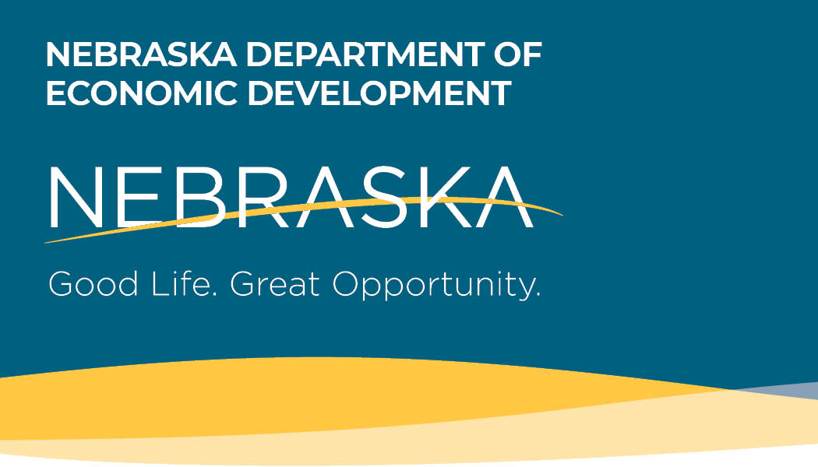
Small Business Stabilization Grants
Frequently
Asked Questions

On March 27, 2020, President Donald J. Trump signed into law the Coronavirus Aid, Relief, and Economic Security Act (the “CARES Act”), which provides federal stimulus funding to states and local governments to help with the response to and recovery from the novel coronavirus (“COVID-19”).
What is the Nebraska Small Business Stabilization Grant?
The Nebraska Small Business Stabilization Grant provides financial assistance to Nebraska-owned small businesses that have been severely impacted by COVID-19. Small businesses and their related industries are the lifeblood of our economic system, and their survival and growth are paramount. Stabilization Grants can provide working capital to small businesses to help them cover their operating expenses.

Who is eligible to apply?
Any Nebraska-owned for-profit business that has 5 to 49 employees and has suffered a negative economic impact from COVID-19 is eligible to apply for Stabilization grants. The following NAICS Codes are NOT eligible: NAICS 21: Mining; NAICS 22: Utilities; NAICS 52: Finance and Insurance; NAICS 55: Management of Companies and Enterprises; NAICS 6: Educational Services; NAICS 92: Public Administration; and any Lobbyist or Political Organization.

Are any businesses ineligible to apply for Stabilization Grants?
The following businesses are not eligible to apply for this program:

- Businesses with more than 49 employees
- Businesses with fewer than 5 employees
- Businesses with the following NAICS codes: NAICS 21: Mining; NAICS 22: Utilities; NAICS 52: Finance and Insurance, NAICS 55: Management of Companies and Enterprises, NAICS 6: Educational Services, NAICS 92: Public Administration; or any Lobbyist and Political Organization
- Businesses past due on Nebraska taxes
- Businesses currently listed on the federal debarment or suspension list (available online at www.SAM.gov)

What are eligible uses of Stabilization Grant funding for businesses?
Eligible uses of Small Business Stabilization Grant funding include working capital and operating expenses for the continuation of a business’ operations.

Are there any prohibited or excluded uses of funds?
The following are not eligible uses of funds:
- Lobbying
- Damages covered by insurance
- Duplication of benefits, including expenses that have been or will be reimbursed under any other federal program
- Reimbursement to donors for donated items or services
- Workforce bonuses other than hazard pay or overtime
- Severance pay
- Legal settlements

How were eligibility requirements determined?
Eligibility was based on information collected by the Office of the Governor, the Get Nebraska Growing Task Force and the Nebraska Department of Economic Development (DED), based on the manner in which limited federal funds could be put to use to help the most people and make the biggest economic impact.

Is a business guaranteed money if approved?
No. Grant money will be distributed on a first come, first served basis.

What are the key program deadlines?
Event | Date(s)
Eligibility submission opening date | June 15, 2020
Eligibility submission deadline | June 26, 2020
Eligibility notification date (via email from the State) | June 15, 2020-June 26, 2020
Application begin date | June 15, 2020
Application deadline | June 26, 2020
Grant award deadline date | August 1, 2020
Period of performance | December 31, 2020

What supporting documentation is required?
Applicants must provide contact information along with their social security number, driver’s license number, federal and state tax identification numbers, industry NAICS Code, their number of employees as of March 13, 2020, as represented by their 941N or other tax records, and bank routing information. Various other documentation may be requested by DED to demonstrate the negative impact COVID-19 has had on the applicant’s business.

What is the process of applying for the Small Business Stabilization Grant?
By June 26, 2020, applicants must have completed the online Eligibility Certification Form (found at www.getnebraskagrowing.nebraska.gov) and provided any necessary supporting documentation to demonstrate grant eligibility. If the business is deemed eligible, the applicant will receive an email containing a certification number, followed by a link to complete the full application.

Will all eligible small businesses receive funding, or is this a competitive process?
All funding will be awarded on a first come, first served basis. It is anticipated that each eligible small business will receive a minimum of $12,000 to help offset the negative impacts of COVID-19 on their operations.

Why are businesses with fewer than five employees not eligible?
The State of Nebraska understands that there is great interest in this program; however, funding limitations require that grant dollars be distributed in a manner that serves as many small businesses as possible and makes the largest possible impact given the resources available. If all categories of business were served, funding would quickly diminish without making a substantial impact for anyone involved.

Why are businesses with more that 49 employees not eligible?
The State of Nebraska understands that there is great interest in this program; however, funding limitations require that grant dollars be distributed in a manner that serves as many small businesses as possible and makes the largest possible impact given the resources available. If all categories of business were served, funding would quickly diminish without making a substantial impact for anyone involved.

Is a business owner be considered an employee?
Yes

Do 1099 or contract employees qualify as employees?
No

Can the employee count be based on the Full-Time Equivalency (FTE) of all my employees?
No

Does the employee count include both full-time and part-time employees?
Yes. This is not an FTE measurement. For example, if you had four full-time and one part-time employee, you would have an employee count of five and be eligible for the grant. But if you had 45 full-time and eight part-time employees, you would not be eligible even though the eight part-time employees would equal four FTE; this would still be considered 53, not 49, employees.

Will any of the grant money have to be repaid?
No, this is a grant and will not be paid back. However, there will be a post-award review, and repayment will be required on the basis of inaccurate or false information.

Will the Small Business Stabilization Grant money received by a business be taxable income?
Consult your tax preparer.

What kind of technical assistance is available to help complete the application process?
Call the Get Nebraska Growing hotline at 855-264-6858 between 7:30 AM and 6:00 PM CST, Monday-Friday.

What is the deadline to apply for funding?
A business must be deemed eligible and complete a full application by 6:00 PM CST on June 26, 2020.

When determining eligibility, how is the number of employees calculated for each small business?
The number of employees is determined by how many persons you had working for you on March 13, 2020. We will require a copy of your 941N, Schedule F or the first page of the most recent tax return.

Does the small business have to demonstrate a negative impact from COVID-19?
The small business must evidence employee layoffs, a loss in revenue or other loss due to COVID-19.

What other information is required?
Businesses will need to detail how they intend to spend the grant funding received.

How will an applicant know they are eligible and can move onto a full application?
After filling out the Eligibility Certification Form, eligible applicants will be notified by email and given a confirmation number allowing them to complete a full application.

How will I know my application has been received?
You will be notified by email.

How do you check the status of an application?
Applicants will be notified by email and given a confirmation number to track their application throughout the process. For assistance, call the Get Nebraska Growing hotline at 855-264-6858 from 7:30 AM -6:00 PM CST Monday-Friday.

How do I determine my business's NAICS Code?
Please go to https://www.naics.com/search/ to search for the code that matches your industry.

When can my business expect to receive funding?
An automatic deposit will be made into the applicant’s designated bank account by August 1, 2020. Funding must be spent by December 31, 2020.

What steps will businesses need to take after receiving funding (compliance, documentation, etc.)?
Please keep all receipts detailing how the money was spent in the event you are chosen for an audit. You will also be expected to fill out a survey at the end of the grant.

Do I need to have an active bank account to receive Small Business Stabilization Grant money?
Yes, you need to have a bank account in order to have the grant money direct deposited into your account when awarded.

Will the application process be available in Spanish?
Yes

If I have received funds from the Small Business Administration from the Paycheck Protection Program or the Emergency Injury Disaster Loan program, can I still be eligible for the Small Business Stabilization Grant?
Yes

